**Alex Abdulla, Eugene Myroniuk**

**COMP3512 Assignment 2**

**Class Design Diagram**

**Explanation:**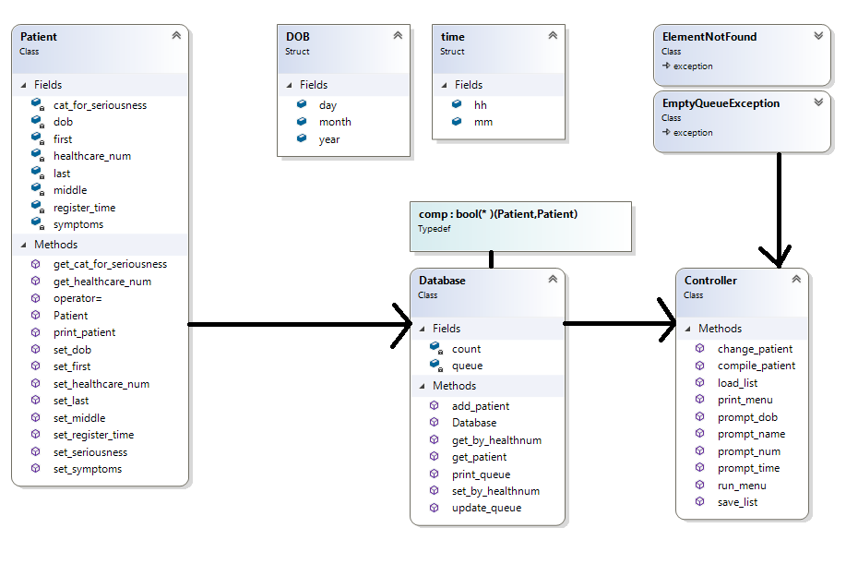

Eugene and I decided to create a Patient class that holds all the necessary information. In order to accommodate the data structure we created two helper sructs: DOB and time. The DOB struct could be refactored into Date to preserve the concept of reusability.

The Database class is the main container and holds all patients in a custom Priority queue. A Custom comparator comp needed to be implemented to allow proper queue management.

The Controller class is the driver of the program. It contains atomic methods for main functionality, and handles all user interactions. It is also responsible for all data validation and exception handling.